**Name – Husaini Bohra**

**Project Name : Starbucks India !**

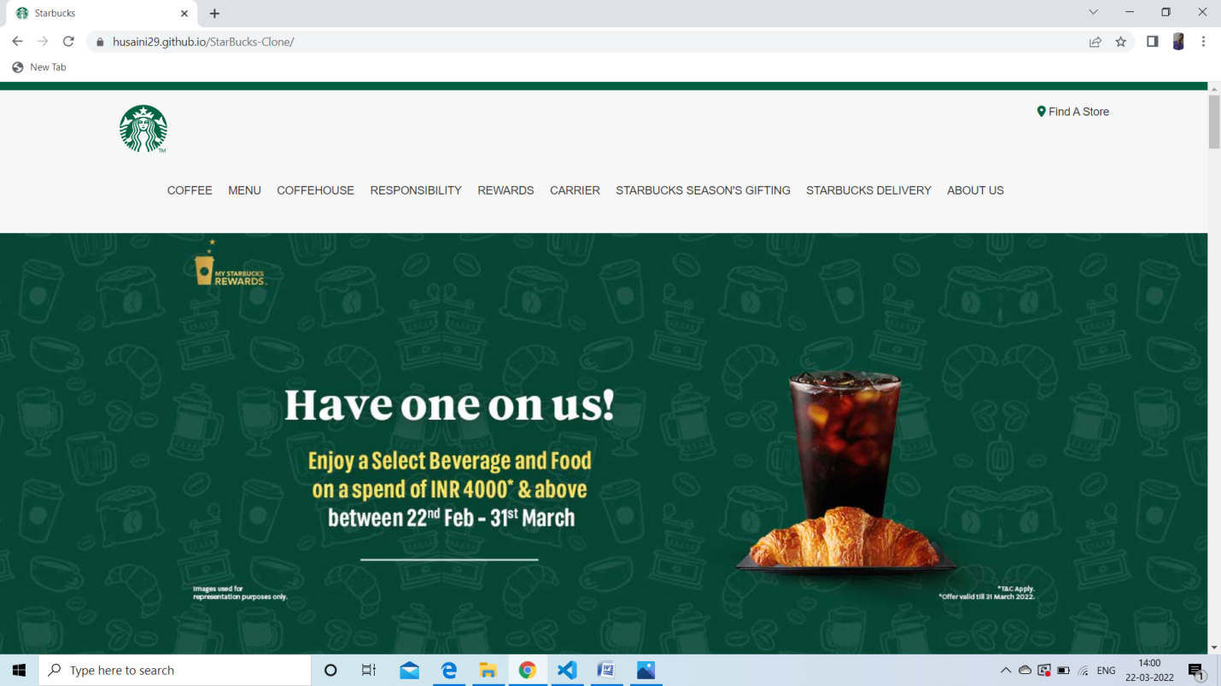

**Overview :** Starbucks Corporation is an American multinational chain of coffeehouses and roastery reserves headquartered in Seattle, Washington. It is the world's largest coffeehouse chain.

As of November 2021, the company had 33,833 stores in 80 countries, 15,444 of which were located in the United States. Out of Starbucks' U.S.-based stores, over 8,900 are company-operated, while the remainder are licensed.

Goals :-

**To inspire and nurture the human spirit – one person, one cup, and one neighborhood at a time.**

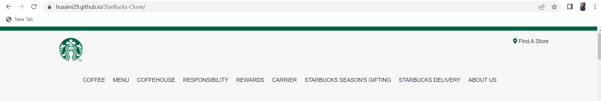

1.Home Page :

The Home page provides various options for user such as Coffee ,Menu ,Rewards ,Find A Store and Many More.

2. COFFEE :

The Coffee Section provides user coffee finder which helps them to find the coffee according to their taste.

3. MENU :

It provides wide range of food and drinks to user so they can choose whatever they like.

4. Find A Store :

Helps user to Find store according to their locations.

5.REWARDS :

Provides a program membership offer Sign in feature ,alongside various giftcards and rewards offer.

6.Carriers :

Starbucks provides various carrier opportunities,internship program ,jobs on their website portal.

7.Delivery :

Also accepting orders and deliverying to your Doorstep.

**Technologies used in this project :**

1.HTML

2.CSS

3.JavaScript